# Building specific and precise prompts

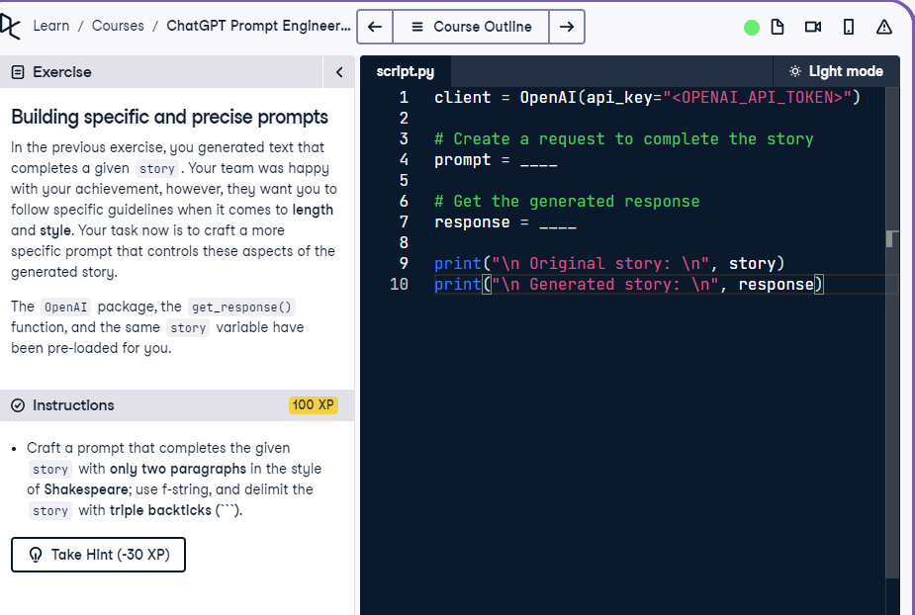

## Question

Craft a prompt that requests two paragraphs in the style of Shakespeare and uses triple backticks to delimit the story.

## Question Explanation

In this task, you need to ask the model to complete the story with specific constraints: two paragraphs in Shakespearean style. The prompt must clearly request these conditions and use triple backticks to enclose the story content for clarity.

## Answer

client = OpenAI(api_key="<OPENAI_API_TOKEN>")  
  
# Create a request to complete the story with the correct length and style  
prompt = f"Complete the following story in the style of Shakespeare, using only two paragraphs. The story is: ```{story}```"  
  
# Get the generated response  
response = get_response(prompt)  
  
print("\n Original story: \n", story)  
print("\n Generated story: \n", response)

## Answer Explanation

The prompt explicitly asks for a continuation of the story in two paragraphs, in the style of Shakespeare, and uses triple backticks to delimit the story content. This ensures that the model will follow the exact format and style requirements.